Lab 7 - WS2812 Fade Controller
Prelab 1
Procedure 1
Overview 1
Overview of Operation 1
Recommended Process 3
Design Validation 3
Verification 4
Extra Credit 4
Postlab 4

Prelab

- Read through the theory of operation and draw a block diagram for the FadingController block in figure 7.2. Be sure your block diagram shows clear symmetry between the red, green, and blue colors. There needs to be at least 6 blocks in your image (more may be better). Your score is based on clarity and neatness.

Procedure

Overview
Creating digital controllers that meet precise timing is a common task for the digital designer. In this lab you will be using your previously created WS2812 driver to build a color blending output by including a memory block and some additional hardware.

Overview of Operation
This system will 'play back' a sequence of 5 colors. The transition between colors needs to take approximately 3 seconds (15 seconds for all colors) and repeat. During the transition between colors, the WS2812 LED must blend smoothly (at least 10 frames per second) and linearly between the colors beginning with the previous color and ending at the new color. To blend between colors, the design will need to adjust each primary color (Red, Blue, Green) linearly from the starting value to the ending value. This means the system will need to calculate a different increment (or decrement) value for each color as the difference between each primary color may not be the same.
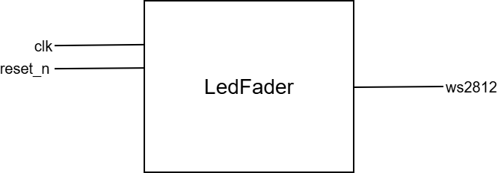
Figure 7.1: Black box diagram of system

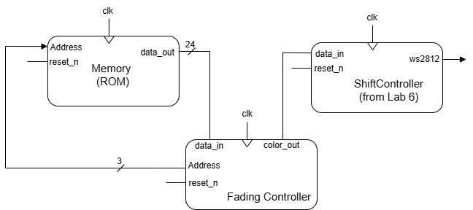
Figure 7.2: Top level block diagram

Interface name | Interface Properties
clk (Input) | - 1-bit value  - 50 MHz(20nS) supplied by DE10 Lite  - Continuously running
reset_n (Input) | - 1-bit value  - Active LOW  - Use DE10 Lite Push button
ws2812 (Output) | - 1-bit value  - Pattern conforming to the WS2812 datasheet for a data input
Table 6.2: Top level block interface

 | Note: In designing and testing this system it is recommended you start by breaking the FadingController into smaller elements and testing them as parts. As you design, the hardware for the Red, Green, and Blue colors will be identical so designing it for only one color and testing might be efficient.

Recommended Process
- Develop the FadingController and test it by applying a single color to the data_in input.

- Modify the FadingController to have an address that increments after each fade is complete so a new value is present on data_in and a new fading process can begin.

- Implement the Memory Module using the 5 values below. Your system needs to fade through these 5 colors in the order presented:
0xFFFFFF (White)
0x0000FF (Red)
0x000000 (Off)
0xFF0000 (Green)
0xFFFF00 (Teal)
- Assuming the simulation works as expected, wire up the supplied WS2812 LED. Be careful of the pins that are used. You need to power the WS2812 from the 5V input supplied on the Arduino connector on the DE10 board. General information and output pins for the Arduino Headers can be found on pages 32 and 33 of the DE10-Lite user manual.
When you power the WS2812 from 5V, do not ever connect the data out from it back to the board. Great care needs to be taken to not hook a 5V signal back to some of the DE10 IO pins as it can destroy the DE10.

As with previous labs, you will need to implement the module using Quartus and show it operating both via Modelsim and on real hardware using the DE10 FPGA development kit. Be sure that you review the expected items for submission on the assignment rubric so you do not forget to produce a project artifact that is required.

Design Validation

Like last lab, you have two options to validate your design:
- Do file: Run simulation long enough to show at least one full blending cycle.
- SystemVerilog testbench: Implement your own built in test bench that verifies at least one full blending cycle.

Verification
When verifying your design with your TA, be sure you are set up ahead of requesting the lab assistant review your work. For this verification you will be expected to show:

- The WS2812 LED changes colors based on expected color pattern. The fading needs to be over approximately 3 seconds per color and needs to seem smooth to the human eye.
- A simulation showing at least one full blending cycle.and you must clearly show and explain this to your TA.
- Correct and complete answers with elaboration to questions your TA may ask
The full rubric and explanation of the checkoff process can be found on the Lab 7 Verification assignment on Canvas.

Extra Credit
This is open for you to try something new and present it to your TA

Postlab
- For this postlab, answer the course feedback from linked as Postlab 7 online.

